​**A REPORT**

**ON**​

**MORSE CODE COMMUNICATIOR FOR**

**THE DEAFBLIND**

**BY**

|  |  |
| --- | --- |
| **MOHAMED FARDEEN** | **2016CSE231** |
| **FATHIHA A F** | **2016CSE267** |
| **SEEKSHA JAIN** | **2016CSE225** |

​

**A**​**T**

**DEPARTMENT OF COMPUTER SCIENCE AND ENGINEERING**

**CSE220 INTERNET OF THINGS**

​**MINI PROJECT REPORT**​



**Presidency University, Itgalpur Rajanakunte, Yelahanka,**​

**Bengaluru**

**ABSTRACT**

We​ get our understanding about the environment with the help of our senses.

Our senses like Touch, Sight, Smell and Audio are the most common. But for the sensorially challenged candidates these senses don’t entirely work. But needless there are ways they use to communicate. The Blind use Braille to read. But the Deaf Blind these days are taught one of the oldest forms of electronic communication that has now become obsolete, “Morse Code”.

We aim to use Morse Code to let the Deaf Blind and the most other Sensorially challenges to easily communicate once they learn and understand Morse Code.

**KEYWORDS:**

​Morse Code, Haptic Feedback, Dots and Dashes, Communication​.

**1. INTRODUCTION**

Using Arduino compatible devices we can create a classic example of a Telegraph Device to Help the Deaf Blind to communicate. The goal is to use few of the many Arduino compatible devices and enable them to yield output in the form of Morse Code. Which the Sensorailly challenged understand.

**2. COMPONENTS REQUIRED:**

* NodeMCU
* Piezo / Buzzer
* Haptic motor
* Jumper Cable
* Power Source
  1. **NodeMCU**

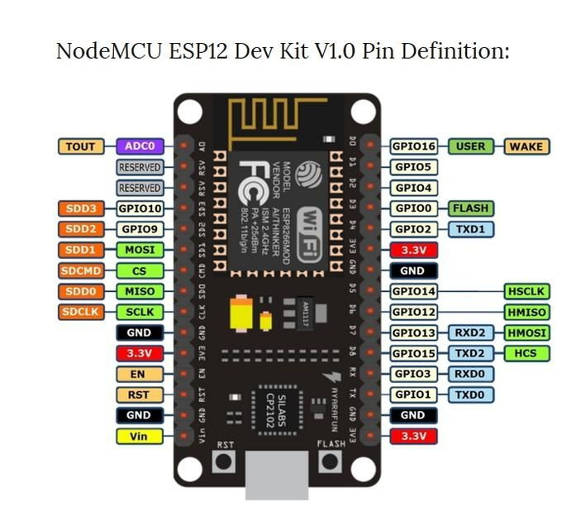

NodeMCU​ is an open source LUA ​​based firmware developed for ESP8266 WiFi chip. By exploring functionality with ESP8266 chip, NodeMCU firmware comes with ESP8266 Development board/kit i.e. NodeMCU Development board. Since NodeMCU is open source platform, their hardware design is open for edit/modify/build. NodeMCU Dev Kit/board consist of ESP8266 wifi enabled chip. The ESP8266​ is a low-cost Wi-Fi chip developed by Espressif Systems with TCP/IP protocol. For more information about ESP8266, you can refer ESP8266​ WiFi Module.

There is Version2 (V2) available for NodeMCU Dev Kit i.e. **NodeMCU**​ **Development** **Board v1.0 (Version2)​**,which usually comes in black colored PCB.

**B. PIEZO/ BUZZER****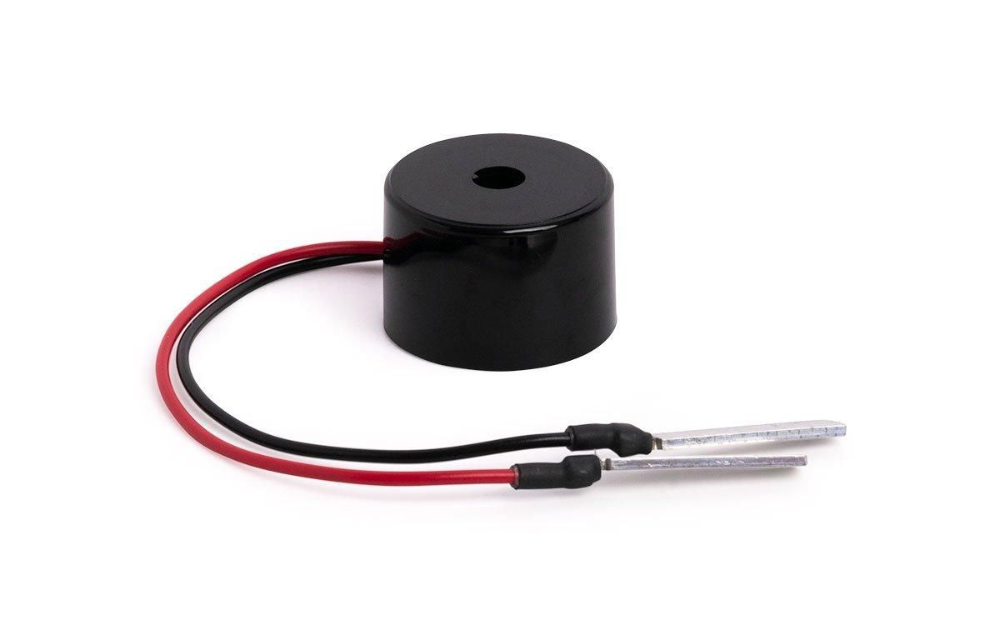**

​

**Piezo buzzer**​ is a type of electronic device that's used to produce a tone,alarm or sound. ​The ​**piezo buzzer**​ produces sound based on reverse of the piezoelectric effect. The generation of pressure variation or strain by the application of electric potential across a piezoelectric material is the underlying principle. ​These buzzers can be used alert a user of an event corresponding to a switching action, counter signal or sensor input. They are also used in alarm circuits.

The buzzer produces a same noisy sound irrespective of the voltage variation applied to it. It consists of piezo crystals between two conductors. When a potential is applied across these crystals, they push on one conductor and pull on the other. This, push and pull action, results in a sound wave. Most buzzers produce sound in the range of 2 to 4 kHz.

The Red lead is connected to the Input and the Black lead is connected to Ground.

**C. HAPTIC MOTOR**

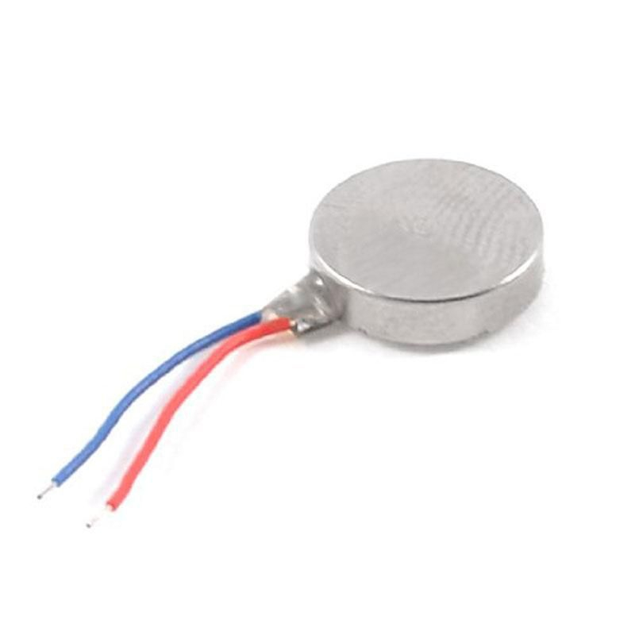

Haptic Motors are Eccentric Rotating Mass (ERM) Motors that provide an effective way for designers to incorporate haptic feedback into their devices. ERM Motor platforms are available in both shaft and coin configurations. These configurations differ with respect to the plane in which the rotating mass spins. This difference defines their overall mounting and package sizes. ERM Motors create vibrations by utilizing a rotating eccentric weight. These haptic effects are customized by controlling the speed of the motor at start up, during operation and at braking.

ERM Motors are very suitable for applications which require a small, low power device. These motors; however, have an inherently high response time due to the need to spin the rotating mass up to speed and brake it back to zero. As a result, the "on" and "off" edges of the haptic effect are more rounded and less sharp as perceived to the end user. As such, these motors are very suitable for applications where simple haptic effects are the preferred mode of communication for the human-machine interface (HMI).

**D. JUMPER CABLES**

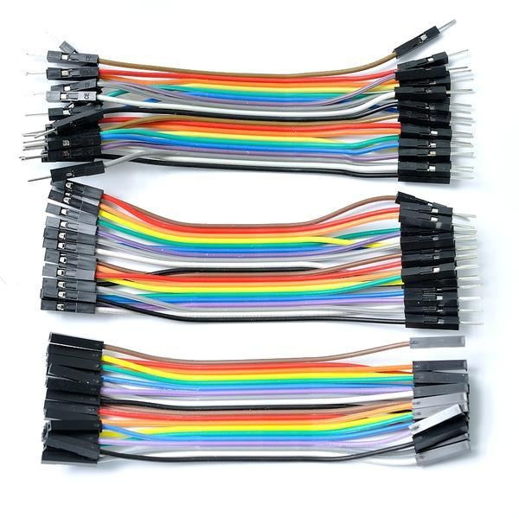

A ​**jump wire**​ (also known as jumper wire, or jumper cable) is an electrical wire​, or a group of them in a cable, with a connector or pin at each end (or sometimes without them – simply "tinned"), which is normally used to interconnect the components of a ​breadboard ​or other prototype or test circuit, internally or with other equipment or components, without soldering.

Individual jump wires are fitted by inserting their "end connectors" into the slots provided in a breadboard, the ​header connector​of a circuit board, or a piece of test equipment.

**E. POWER SOURCE****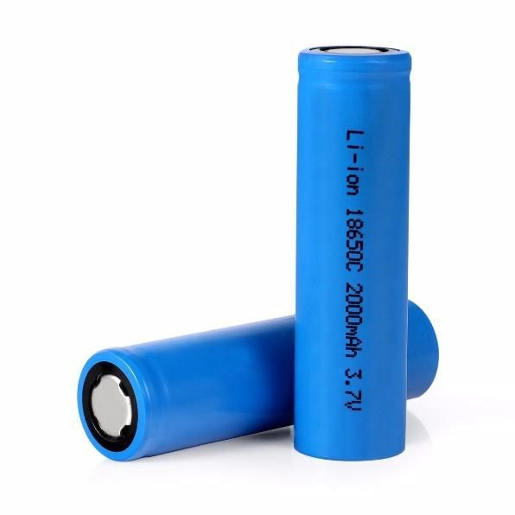**

A ​**rechargeable battery** ​, ​**storage battery**​, or ​**secondary cell**​, (or archaically ​**accumulator**​) is a type of ​electrical battery​which can be charged, discharged into a load, and recharged many times, as opposed to a disposable or ​primary battery​, which is supplied fully charged and discarded after use. It is composed of one or more ​electrochemical cells​. The term "accumulator" is used as it ​accumulates​and ​stores energy​through a reversible ​electrochemical​​reaction​. Rechargeable batteries are produced in many different shapes and sizes, ranging from ​button cells​to megawatt systems connected to ​stabilize​an ​electrical distribution network​. Several different combinations of ​electrode​​materials​and ​electrolytes​are used, including ​lead–acid​, ​nickel–cadmium​(NiCd), ​nickel–metal hydride​(NiMH), ​lithium-ion​(Li-ion), and ​lithium-ion polymer​(Li-ion polymer).

Rechargeable batteries typically initially cost more than disposable batteries, but have a much lower ​total cost of ownership​and ​environmental impact​, as they can be recharged inexpensively many times before they need replacing. Some rechargeable battery types are available in the same ​sizes​and voltages as disposable types, and can be used interchangeably with them.

**3. WORKING**

Message is sent from the BLYNK app to the NodeMCU over WiFi. This message is then converted into morse code format by the program. The resulting is given as input to the Piezo or Haptic motor which outputs in form of Dots and Dashes which the DeafBlind can understand.

**4. CONCLUSION**

The IoT project was completed and the device was able to decode messages sent wirelessly and depict it in the form of Morse Code serving the devices purpose.